Travels of a Raindrop: How Stormwater Runoff Pollutes Our Rivers

A raindrop that falls from the sky needs to go somewhere. When a raindrop cannot soak into the soil, it instead travels across the ground and becomes stormwater runoff.
As it flows across the landscape, the raindrop picks up whatever it comes in contact with, such as pet waste, fertilizer, pesticides, road salt, oil from cars, trash and soil particles. The runoff is eventually channeled into storm drains that connect directly to rivers and streams. Since stormwater is not treated like wastewater, all the pollutants a raindrop picks up along the way are brought into the river.
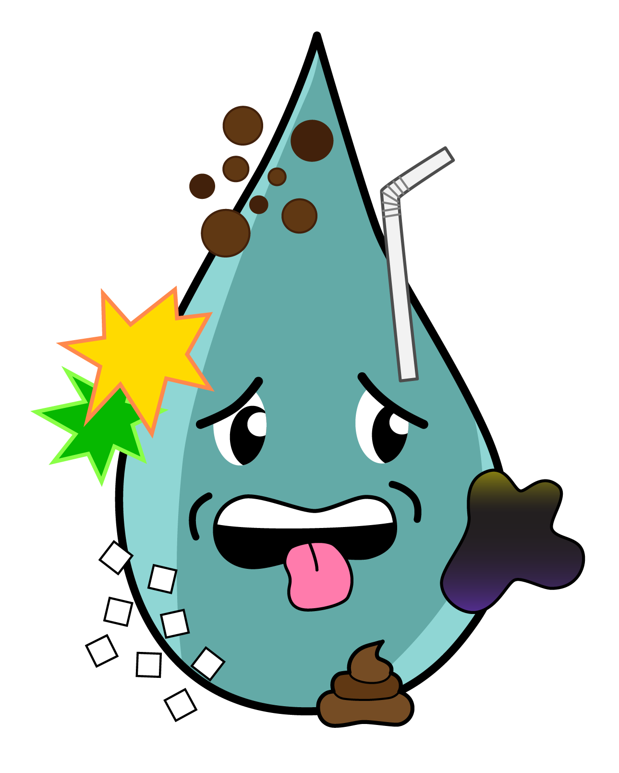
Polluted stormwater runoff contaminates our local rivers and streams. The nutrients in fertilizers, pet waste and soil feed algae. Algal blooms can further pollute the water, limit recreational opportunities and kill off aquatic life by depleting oxygen in the water.

How can I help limit polluted water from entering our rivers?

When rain falls to the ground it either soaks into the soil and becomes groundwater, or it flows over the ground and becomes runoff. We want to keep it where it falls. As rainwater absorbs into the ground, the pollutants are filtered out, and the water entering groundwater is clean.
Plants, especially plants native to our area, can be key resources for limiting water pollution. Deep-rooted native plants soak up and infiltrate much more water than turf grass. To help a raindrop that falls on your lawn or roof absorb into the ground, consider adding a rain garden to your yard.
A rain garden is planted with rain-loving plants in a depression in your yard. The stormwater that falls on your property will collect there and slowly absorb into the garden instead of running off. Be sure to direct your downspout to the rain garden! Rain gardens keep pollutants out of local waterways and help recharge our groundwater supply.
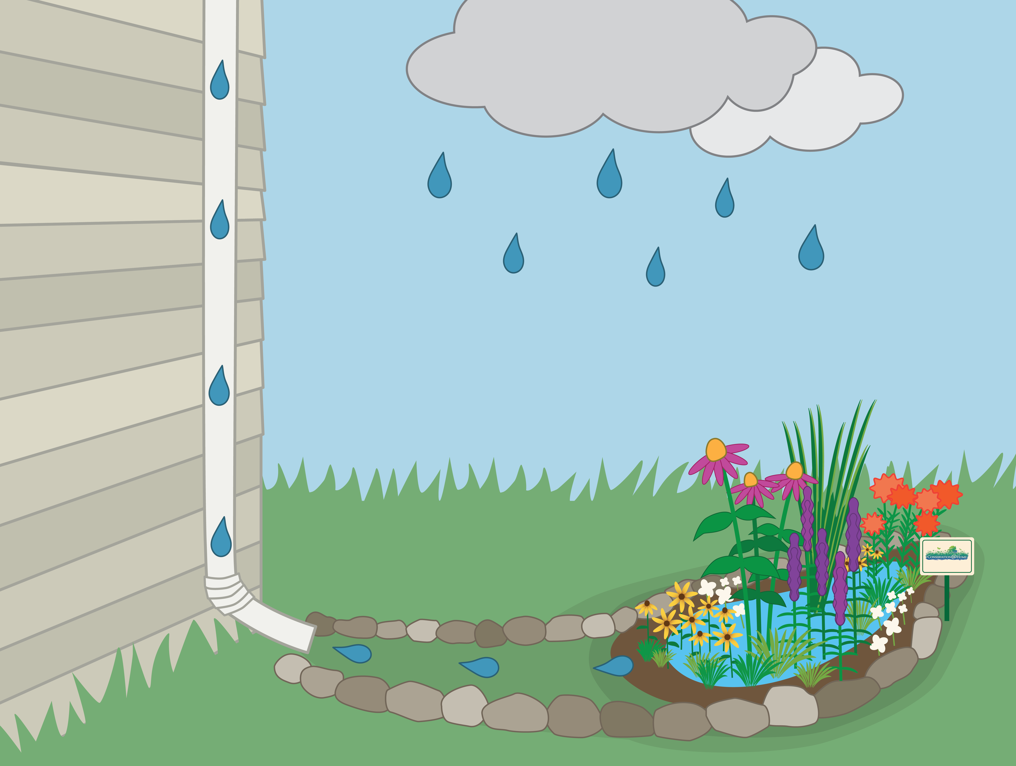
Another way to use rainwater as a resource is to purchase a rain barrel and hook it up to your downspout to collect water to be used for later. Use the rainwater to water gardens or house plants, for pet care, and to wash cars. In addition to keeping our rivers clean, collecting rainwater on your property can lessen the stress on storm water systems, reduce flooding in your neighborhood, and reduce your water bill.
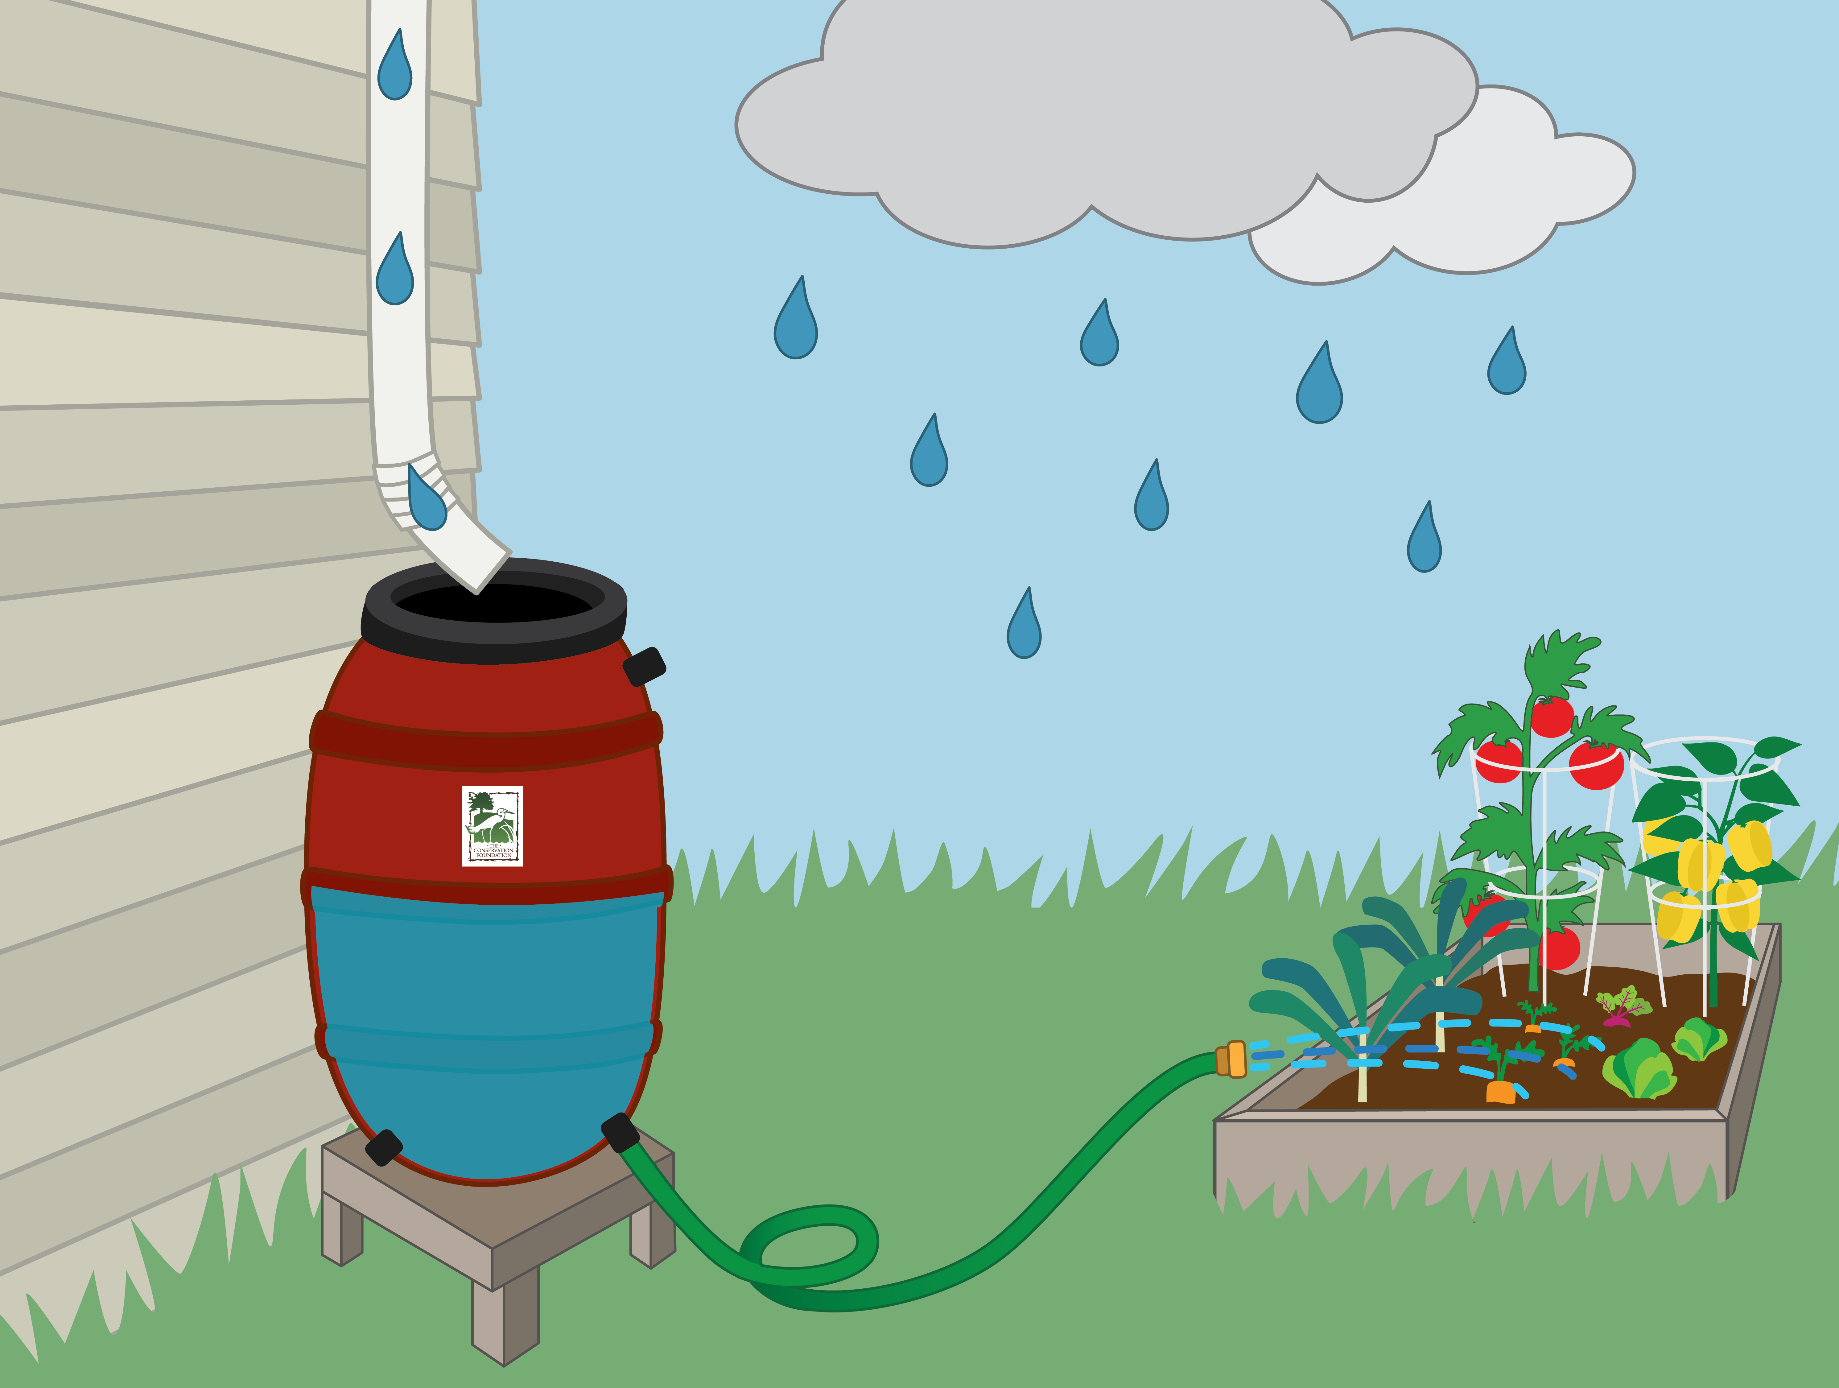

Where can I get native plants and rain barrels?

There are several native plant sales in the spring. Chicago Living Corridors has an extensive list of local native plant sales at https://chicagolivingcorridors.org/native-plant-sales/
Native plants are also available from these growers:
Natural Communities Native Plants
812 N Washington Ave
Batavia, IL 60510
(331)-248-1016
https://naturalcommunities.net/

Possibility Place Nursery
7548 W. Monee-Manhattan Road
Monee, Illinois 60449
(708)-534-3988
https://www.possibilityplace.com/

The Growing Place
2000 Montgomery Road
Aurora, IL 60504
(630)-820-8088

AND
25w471 Plank Road
Naperville, IL 60563
(630)-355-4000
www.thegrowingplace.com

Wondering what native plants are best for your yard? Read more about them on The Conservation Foundation’s website.
We offer rain barrels for sale online for 64.50 plus tax. Our rain barrels are made from repurposed, food-grade containers that are less expensive than rain barrels sold at retail stores.

Other Solutions to Stormwater Runoff

As a property owner, it’s best to start at home, with a rain barrel or rain garden, to help keep our rivers clean. However, you may have the opportunity to support projects in your community that can lessen the negative impact of polluted runoff on local waterways, such as:
Protecting open space. As we keep developing land—covering it with buildings and concrete—we increase the area a raindrop will travel across as runoff and pick up pollutants. Conserving open space allows more rain to soak into the ground where it falls.
Green infrastructure, such as permeable pavement, green roofs and bioswales. Green infrastructure, especially as a part of redevelopment, can be important for cities and suburbs with less open space.

