This Fall, Use Leaves as a Resource!
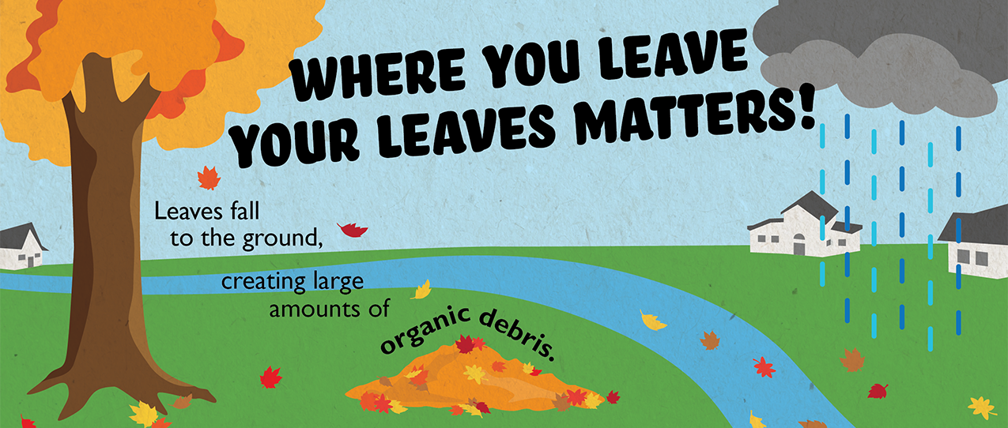

As we transition into fall, we switch from mowing the lawn to raking leaves. Unfortunately, leaves often end up on the street where they can be washed into storm drains, back up stormwater, and enter our waterways. The nutrients in leaves cause problems for rivers, streams, and lakes—like feeding the growth of mucky green algae.

However, if we use leaves as a resource instead of as a waste product, we can help our lawn and protect waterways at the same time! Read on for a few ways we can use leaves to our benefit.

Three Ways to Take Care of Fall Leaves
1. Mulch
Mulching leaves is a great way to take advantage of the nutrients in leaves. Simply mow leaves along with your grass and allow the resulting material to break down into the lawn. The shredded leaves and grass clippings create a useful combination of nutrients, including phosphorus and nitrogen, which can naturally fertilize your lawn. This works best if you do not have a large amount of leaves.
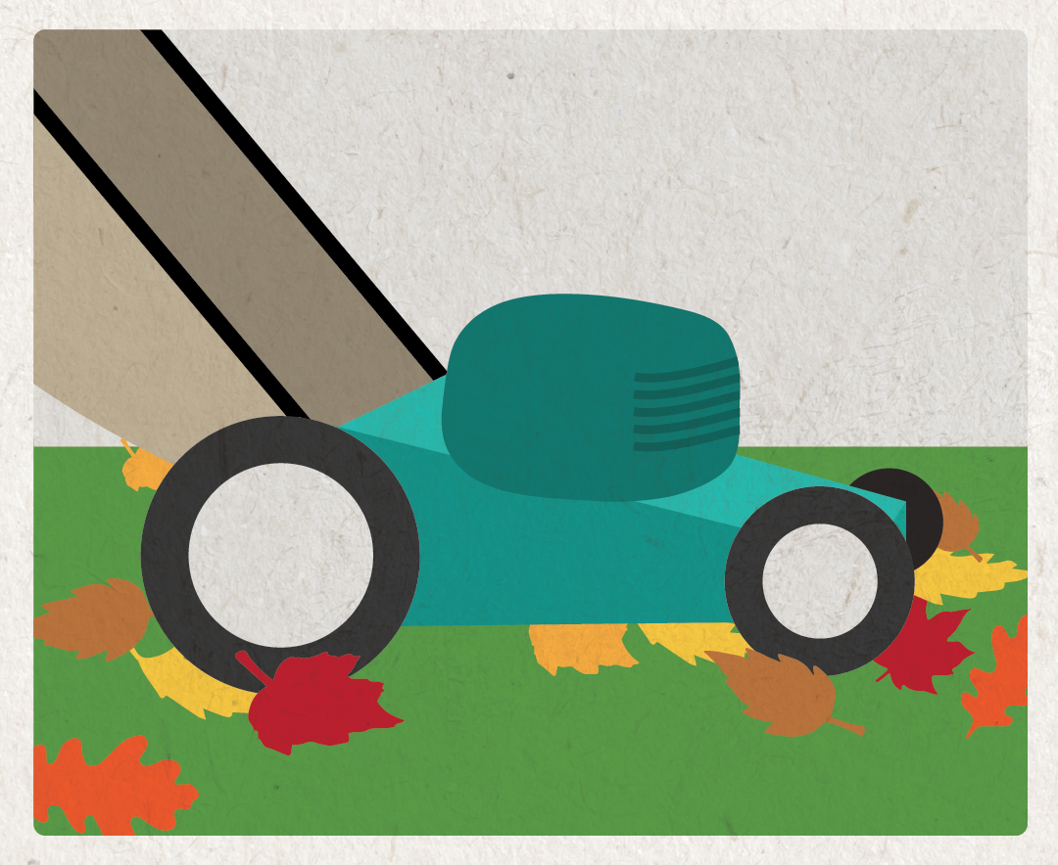
2. Compost
Composting your leaves is a convenient way to dispose of leaves in a way that will benefit your garden. When leaves decompose they create a nutrient-rich compost that will increase the quality and fertility of your soil.
Leaves generally take a long time to decompose. Mulching them first will quicken the decomposition. First, mulch and collect leaves with the bag attachment on your lawn mower. Then, add the mulched leaves directly to your gardens and landscaping, or store them in a compost bin to use next year. In the spring, incorporate the decomposing leaves into the soil to nourish your plants.
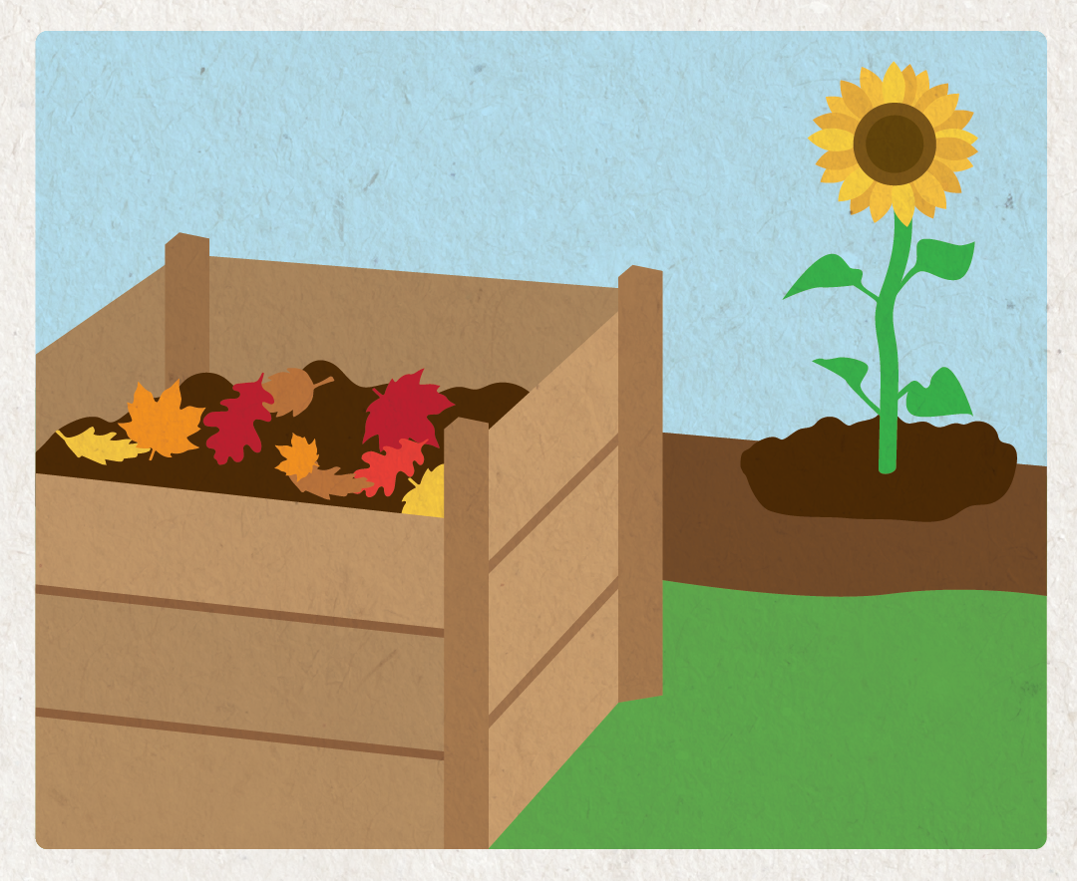
3. Bag of Rake to the Curb
If you can’t use leaves at home, take part in your community’s leaf collection program. Check your community’s website to learn how and when leaves will be collected in the fall. Bagged or raked to the curb, just keep them out of the street!
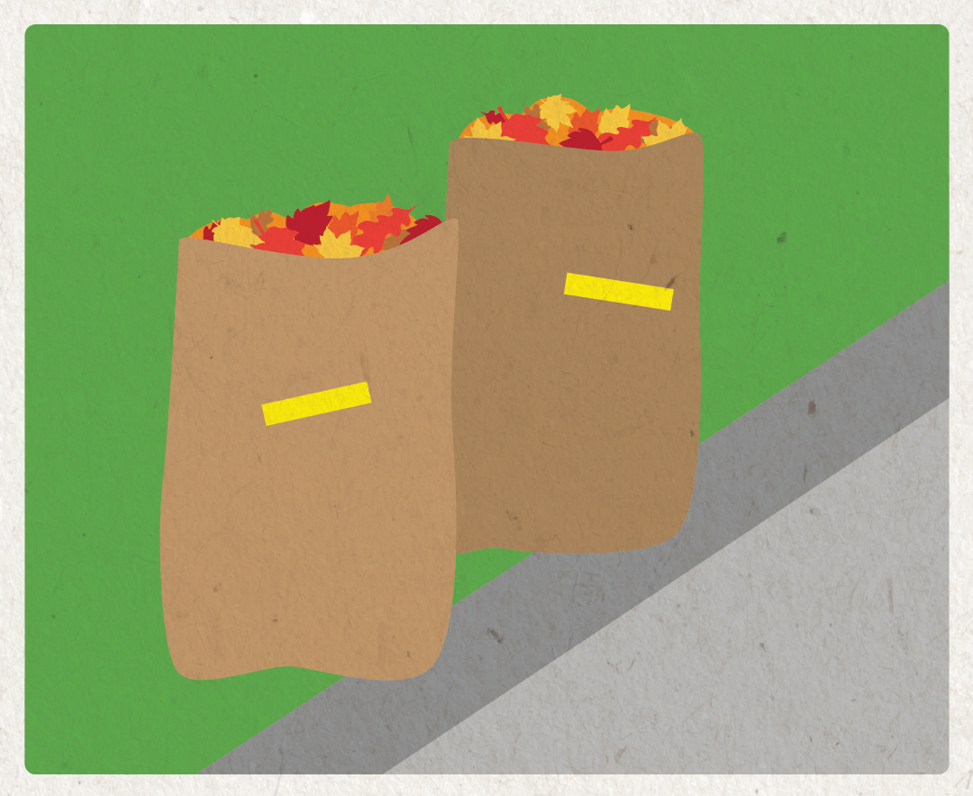
Many community leaf collection programs ask that you bag your leaves and place them by the curb.
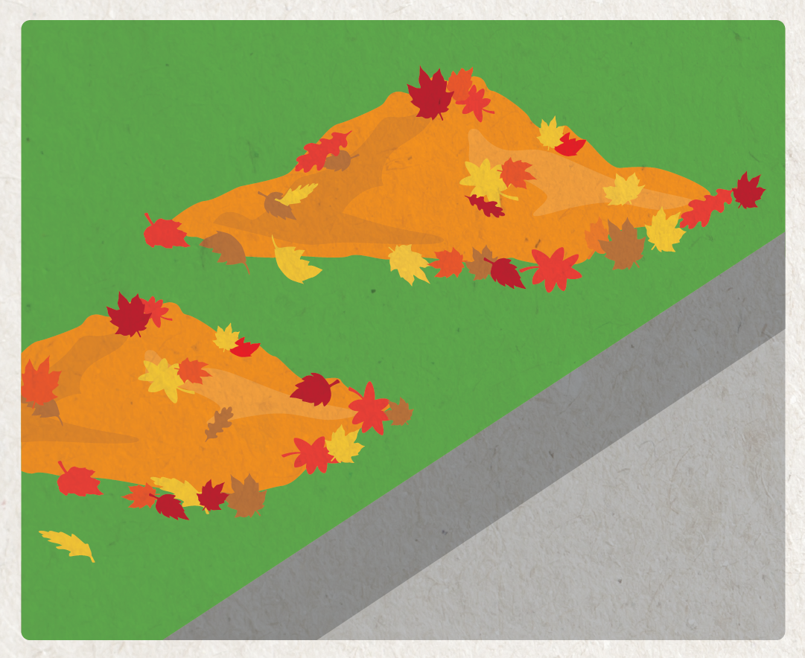
And some communities require you to rake leaves to the curb, but not into the street!

While raking leaves in your yard, be sure to rake or sweep leaves out of the street as well, especially before a storm. Taking care of leaves properly keeps our community looking good and prevents loose leaves from causing problems in our storm drains and local waterways. By taking care of our leaves responsibly, we can keep our yards and rivers healthy and beautiful.
For more environmentally-friendly landscaping tips, learn about The Conservation Foundation’s Conservation@Home program at https://www.theconservationfoundation.org/conservation-home/

