Maintain Your Septic System to Save Money and Protect the Environment

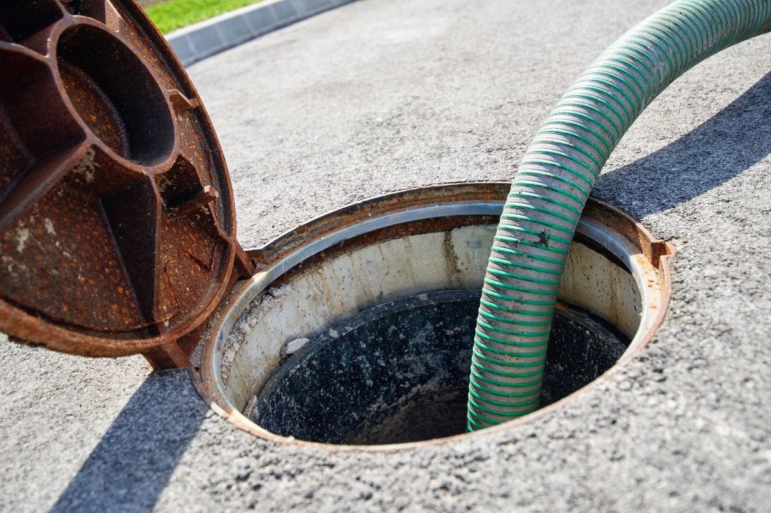

Avoid big bills, nasty backups, and environmental harm by keeping your septic system in good shape! You can dodge most septic system issues with simple, everyday practices and periodic maintenance.

How Septic Systems Work
If your home has a septic system, whatever you send down the drain—through your sinks, toilets, showers, bathtubs, and washing machine—is sent to the septic tank and treated on your property instead of at a municipal wastewater treatment plant.
Water flows from the drains in a house to a central pipe and into a septic tank. In the tank, solid waste settles at the bottom of the tank and is broken down by beneficial bacteria. Solids at the bottom are typically referred to as the sludge layer. Grease and oil that enter the septic system form a “scum” layer that floats at the top of the tank.
The water between the sludge layer and the scum layer discharges into the septic field, a series of buried pipes that slowly disperse wastewater into gravel and the soil beneath. The wastewater is further treated as it passes through the gravel and soil. By the time the water rejoins groundwater, coliform bacteria, nutrients, and other contaminants are filtered out.

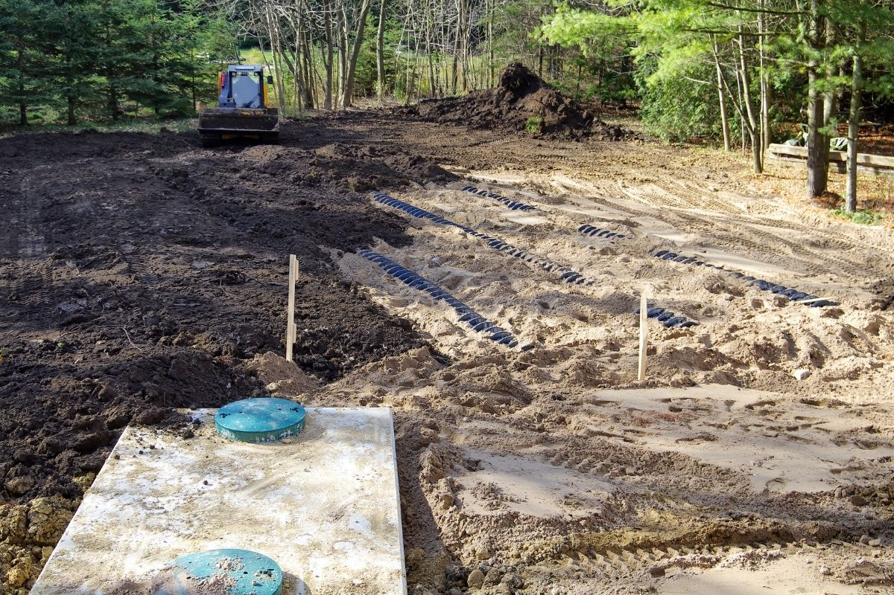

Maintenance Matters
While the technology behind a septic tank and field is fairly simple, a septic system isn’t a “set and forget” system. Everyday practices and routine maintenance will keep your septic system in working order.
Malfunctioning septic systems can cause backups of untreated wastewater in your home or overflows in your yard near the septic tank. An overflow of untreated wastewater can contaminate the groundwater and nearby ponds, rivers, or streams. If there is a backup or overflow, call a septic tank contractor immediately to prevent expensive repairs and further environmental contamination.

How to Maintain Your Septic System
With proper maintenance, homeowners can avoid most septic system issues. Whatever you put down the drain impacts your septic system, so be mindful to only put what your septic system is designed to handle—human waste, toilet paper, and water—down the drain. Avoid putting the following down the drain and into your septic system:
- Any solids besides human waste and toilet paper. This includes wipes, paper towels, coffee grounds, feminine products, and dental floss. Consider eliminating (or at least reducing) the use of a garbage disposal to help cut back on the amount of oil and solids entering your system.
- Grease and oil from cooking. Too much grease and oil can throw the septic system out of balance and cause blockages. Find ways to reuse cooking grease or throw it in the trash.
- Strong cleaning chemicals, like bleach. Remember, your septic system is a living system that relies on beneficial bacteria to break down waste and clean the water. Harsh chemicals in cleaning products as well as gasoline, oil, pesticides, antifreeze, and paint will kill the bacteria and cause the sludge to build up in the septic tank.
- Medications. Pills and liquid medications can also kill bacteria in the septic system. Leaks and overflows can release medications into the environment.

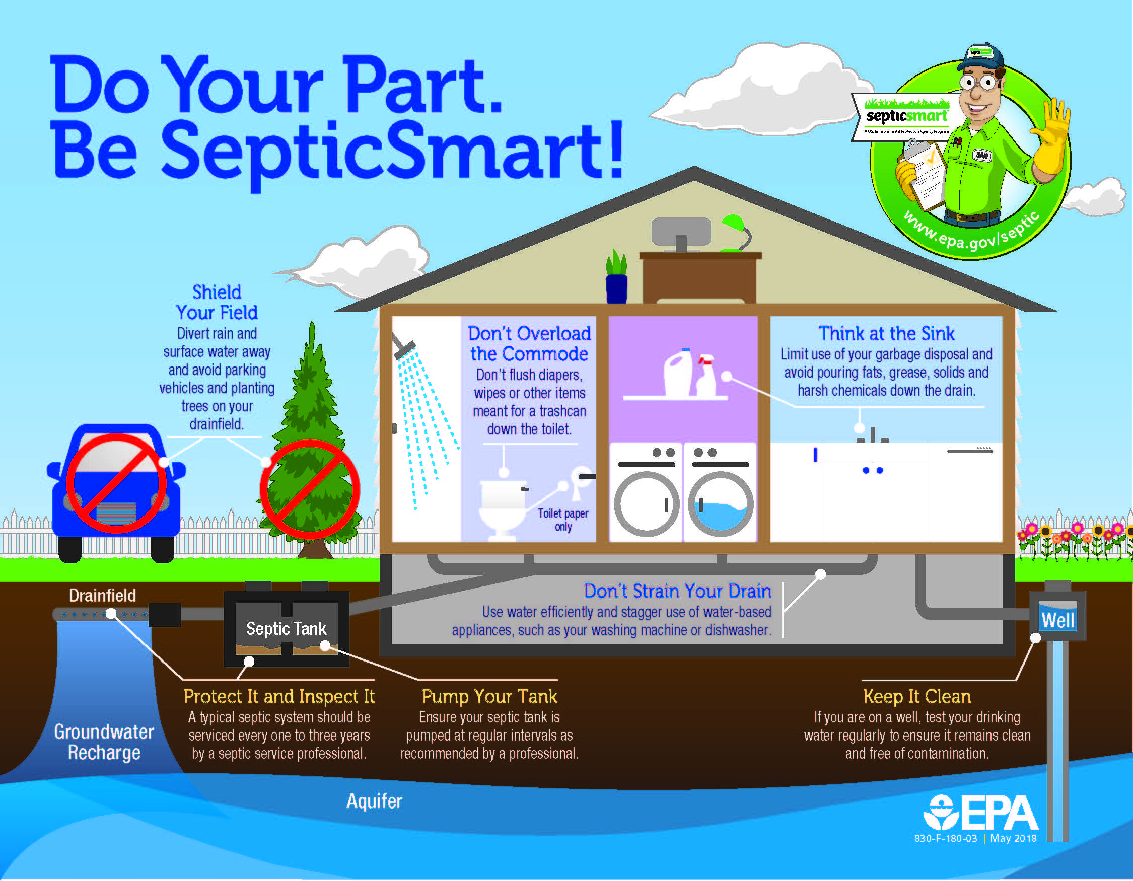
Be SepticSmart! Source: Environmental Protection Agency.

Also consider the amount of water you’re sending into your septic system. The more wastewater entering your system, the greater the strain on your system. Spread out your water usage and conserve water when possible.
In addition to daily care of your septic system, occasional inspections and pumping of your septic tank is required. Pumping clears out the scum layer and excess sludge that build up over time. The Environmental Protection Agency recommends homeowners get their system inspected every three years and have their tank pumped every three to five years.
Finally, protect your drain field. Tree roots can damage the drain field, so plant trees and shrubs away from the field. Direct downspouts and other water sources away from the field. Additional water in the septic field slows down or stops the wastewater treatment process. Also, do not park, drive, or put heavy infrastructure like a swimming pool over the field.
Often, homeowners who are new to septic systems don’t give them much thought until they run into a problem. Homeowners on a septic system can avoid stress, extra costs, and environmental pollution with good habits and routine tank pumping.

