Common Problems Affecting Stormwater Pond Function: Blocked Inlet and Outlet Structures
Detention basins and ponds are important for managing stormwater in our neighborhoods. Stormwater ponds require maintenance to work well. One common problem with stormwater ponds is blocked inlet and outlet structures.

What Are Inlet and Outlet Structures?
Inlet and outlet structures of stormwater detention ponds maintain the water level of ponds to prevent flooding. Stormwater run-off from roads, roofs, and sidewalks enter the detention pond through inlet structures. The water gradually releases to local waterways through outlet structures.
Sometimes inlet and outlet structures fill with trash, sediment, or overgrown vegetation. These materials block water flow. As a result, the area around a detention pond is more susceptible to flooding. Keep these structures clear to allow detention ponds to effectively manage stormwater.

What Blocks Inlet and Outlet Structures?

1. Trash and Debris
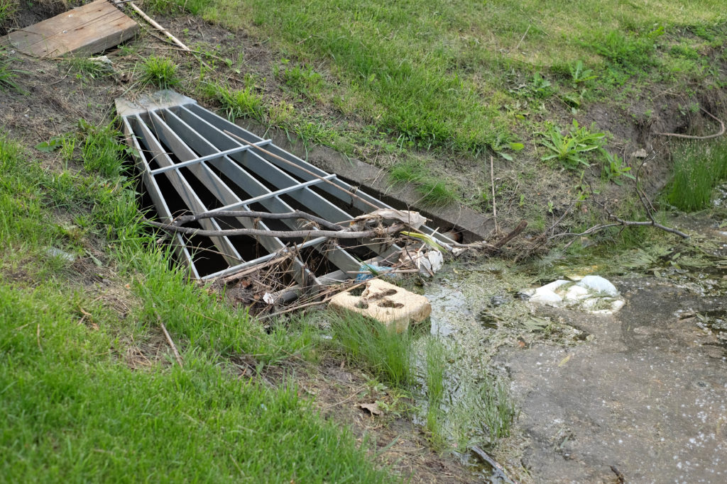
During storms, stormwater run-off can carry trash and debris, like leaves and branches, into a stormwater pond. Over time, trash and debris accumulate and block inlet and outlet structures. It is crucial to continuously remove trash in and around stormwater ponds. Besides stopping water flow, trash can hurt aquatic life and make our local waterways look bad.

2. Sediment
Loose sediment from eroded shorelines and run-off can gather in the inlet and outlet structures, causing a blockage. If you notice shoreline erosion occurring along your stormwater pond, steps should be taken to prevent further erosion and repair the shoreline.

3. Vegetation
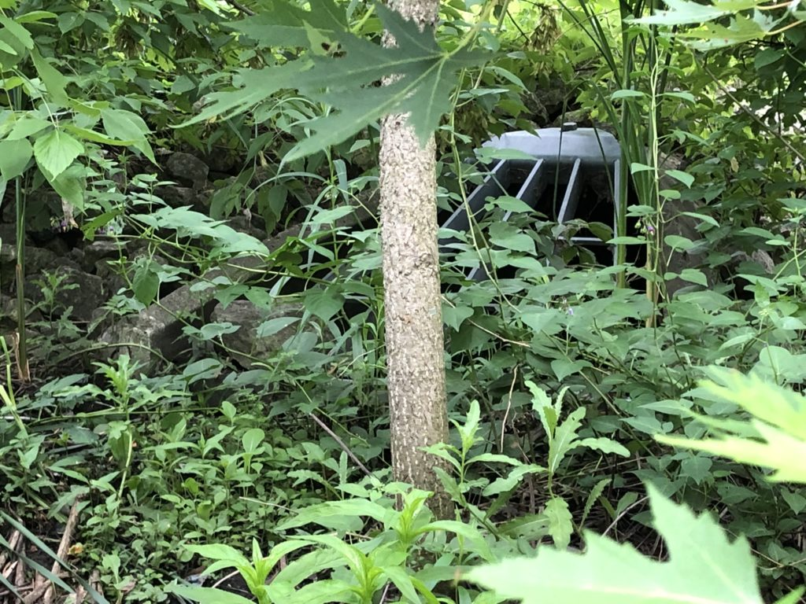
Sometimes vegetation can become overgrown around your inlet and outlet structures. Dense vegetation can slow the flow of stormwater to and from a detention pond. Remove or trim the vegetation around inlet and outlet pipes to avoid blockage.

Other Problems with Detention Pond Structures
Apart from blockage to inlet and outlet structures, there can be other problems associated with the structures, such as cracked or eroded pipes and detached grates. If the structures are damaged, it is best to call an engineer to inspect the inlet and outlet structures.
Grates stop trash and debris from flowing into detention basins and local waterways. Professional assistance may be needed to replace a missing grate.
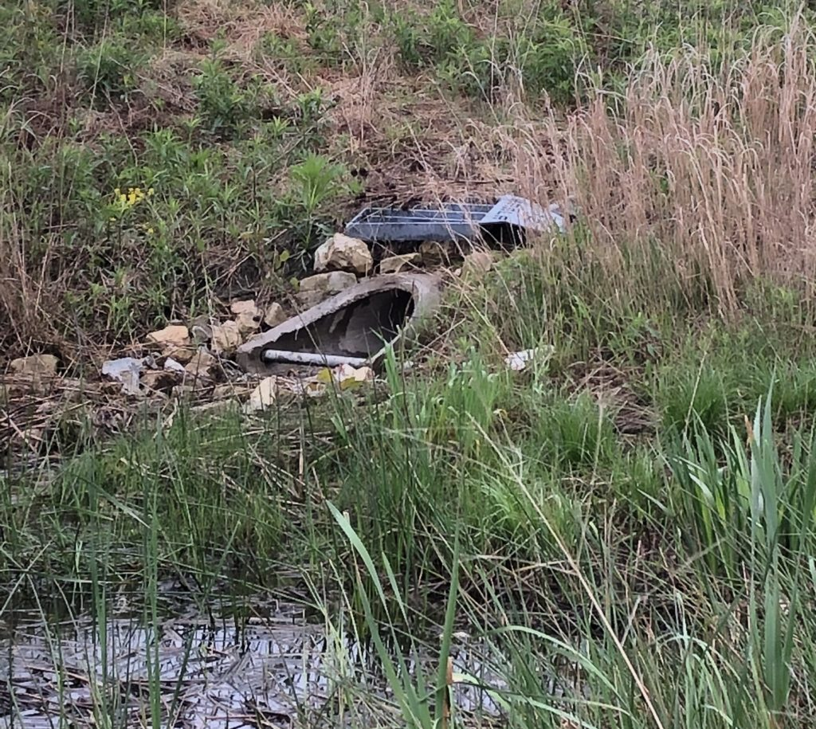
A grate completely detached from an inlet structure.

A well-functioning detention basin contributes to optimal stormwater management.
A detention basin, with clear inlet and outlet structures, can be a key feature of effective stormwater management in your community. Since detention pond structures can easily be blocked by trash, sediment, and vegetation, regular maintenance is required. In addition to monthly inspections, inlet and outlet structures should be inspected for blockage after storms to ensure proper flow of stormwater and function of the detention pond.

